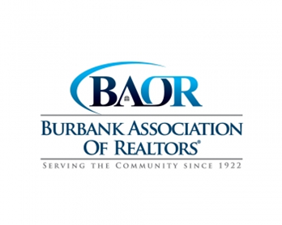
Burbank Association of Realtors®
2006 W. MAGNOLIA BLVD.
BURBANK, CA 91506

PHONE (818) 845-7643 FAX (818) 845-1802 www.burbankrealtors.org

ADVERTISING RATES: WEBSITE website 1 year – $400.
(Business card size only)

Newsletter Advertising

Business card size - $30.00 per issue

¼ page $75.00 per issue
½ page $180.00 per issue full page $435.00 per issue

Deadline for next newsletter is the 20th of the month.
Website can go up sooner.

Non-Affiliate Member Rate newsletter and website $900. 1 year
(Business card size only)

Business Card size - $50.00 per issue

¼ page $160.00 per issue
½ page $375.00 per issue
Full page $775.00 per issue

Deadline for next newsletter is the 20th of the month.
Burbank Association of REALTORS®

Newsletter/Website Order Form

Yes, count me in for Member Combo package at $400.00 - 1 Year

Yes, count me in for Non-member Combo package at $900 - 1 Year

Newsletter Only

Yes, count me in for Newsletter Only at: $ per issue 1 Year

Yes, count me in for Newsletter Only at: $ per issue 1 Year

Name Phone

Firm Name

Address

City Zip fax

e-mail

Pay by Check
Pay by Credit Card

Credit Card Amount $

Type of card (circle one) Visa Master Card American Express

Credit Card Acct. No.

Expiration date
3 – 4 security code

Billing zip code

Authorized Signature

